

Project Report on

“GO-KART”

*Submitted by*

Chetan Salunke (19BME1095)

Divesh Thakur (19BME1089)

Harshit Sharma (19BME1090)

Saurabh Sharma (19BME1087)

*In partial fulfillment of requirements for the award of degree in*

*Bachelor of Engineering in Mechanical Engineering*

(2019-2023)

Under the Guidance of

**Prof. Munish Kumar**

**INDEX**

* Introduction -------------------------------------------------------------------------- 6
* Application of Electric go-kart ---------------------------------------------------- 7
* Wheels ----------------------------------------------------------------------------------10
* Frame Design --------------------------------------------------------------------------13
* Steering System------------------------------------------------------------------------21
* About battery ---------------------------------------------------------------------------37
* Braking System ------------------------------------------------------------------------38
* Motor ------------------------------------------------------------------------------------38
* Speed Controller -----------------------------------------------------------------------39
* Manufacturing rules -------------------------------------------------------------------43
* Complete 3D views -------------------------------------------------------------------52
* Safety ------------------------------------------------------------------------------------53
* Approximate cost ----------------------------------------------------------------------55

**CONTENTS**

**CHAPTER**

## Introduction --------------------------------------------------------------6

## Literature Review --------------------------------------------------------7

## 

Brief History of Go-kart -------------------------------------------------------------7

Components of Go-karts -------------------------------------------------------------8

Chassis ---------------------------------------------------------------------------------8

Engine ----------------------------------------------------------------------------------9

Transmission system -----------------------------------------------------------------9

Tires -----------------------------------------------------------------------------------10

1. **Methodology ----------------------------------------------------------------11**

**Design ----------------------------------------------------------------------------------12**

**Frame ----------------------------------------------------------------------------------13**

Design Objectives ---------------------------------------------------------------------14

Considerations -------------------------------------------------------------------------15

Testing and Calculations -------------------------------------------------------------16

1. **Steering System ------------------------------------------------------------21**

Design Objectives ----------------------------------------------------------------------22

Considerations --------------------------------------------------------------------------23

Calculations -----------------------------------------------------------------------------24

1. **Axle ----------------------------------------------------------------------------28**

Design Objectives --------------------------------------------------------------------28

Live axle for traction -----------------------------------------------------------------28

Differential -----------------------------------------------------------------------------28

Single wheel drive ---------------------------------------------------------------------28

Tandem Axle ---------------------------------------------------------------------------29

Considerations --------------------------------------------------------------------------29

Testing and Calculations --------------------------------------------------------------30

1. **Drive Train -------------------------------------------------------------------30**

Design Objectives -----------------------------------------------------------------------30

Engin --------------------------------------------------------------------------------------30

Engine Mounting ------------------------------------------------------------------------31

Chain and Sprocket ----------------------------------------------------------------------32

Transmission ------------------------------------------------------------------------------32

Muffler and Exhaust ---------------------------------------------------------------------32

Considerations ----------------------------------------------------------------------------33

Testing and Calculations ----------------------------------------------------------------33

1. **Electric motor -----------------------------------------------------------------36**

About Battery -----------------------------------------------------------------------------37

Lithium-ion battery -----------------------------------------------------------------------38

1. **Brakes and Wheels ------------------------------------------------------------38**

Design Objectives------------------------------------------------------------------------39

Considerations----------------------------------------------------------------------------39

1. **Bodyworks-----------------------------------------------------------------------45**

FRP ----------------------------------------------------------------------------------------45

Advantages and limitations-------------------------------------------------------------45

Failure Modes ----------------------------------------------------------------------------45

Design Considerations ------------------------------------------------------------------46

Manufactured Fiber Parts ---------------------------------------------------------------46

Front Fairing -----------------------------------------------------------------------------47

Front Panel -------------------------------------------------------------------------------47

Side Fairing-------------------------------------------------------------------------------48

Seat ------------------------------------------------------------------------------------48

1. **Aesthetics ---------------------------------------------------------------------50**
2. **Ergonomics -------------------------------------------------------------------50**
3. **Safety Protocols -------------------------------------------------------------53**
4. **Cost Report -------------------------------------------------------------------54**
5. **Business Plan -----------------------------------------------------------------55**

Marketing and Capital Generation ------------------------------------------------55

Starting Pro Racing ------------------------------------------------------------------56

Plant Setup ----------------------------------------------------------------------------56

1. **Future Scope and Improvement ----------------------------------------57**
2. **Achievements ---------------------------------------------------------------58**
3. **Conclusions -----------------------------------------------------------------58**
4. **References -------------------------------------------------------------------59**

1. **Introduction**

Everything in life begins with hope. Hope backed by effort is what made tangible. Is a coalition of all our endeavors and uphill battles. It is the shape, given to efforts of the students of Department of Mechanical Engineering, Chandigarh university, who thought to fabricate a vehicle in college campus situated at very isolated place.

By definition of International Karting Commission – Federation International Automobile (CIK-FIA), a kart is defined as a land vehicle with or without a bodywork, with 4 non-aligned wheels in contact with the ground, two of which control the steering while the other two transmit the power. Its main parts are the chassis (which consists of a body frame work that is made up of a set of bent steel pipes that are welded together) with an engine, four wheels and tires attached on it.

According to Wikipedia, a go-kart (sometimes known as a "go-cart" or just kart) is a small four-wheeled vehicle. Go-karts come in all shapes and forms, from motor less models to high-powered racing machines, some, like Super karts, being able to beat racing cars on long circuits. Gravity racers, usually referred to as Soap Box Derby carts, are the simplest type of go-karts. They are propelled by gravity, with some races taking place down a single hill. Amusement park go-karts can be powered by 4-stroke engines or electric motors, while racing karts use small 2-stroke or 4-stroke engines. Most of them are single seated but recreational models can sometimes accommodate a passenger. In some countries, go-karts can be licensed for use on public roads. Typically there are some restrictions, e.g. in the European Union a gokart on the road needs head light (high/low beam), tail lights, a horn, indicators and a maximum of 20hp. Besides traditional kart racing, many commercial enterprises offer karts for rent, often called "recreational" or "concession" karts. The tracks can be indoor or outdoor. Karts are rented by sessions (10 to 15 minutes usually), they use sturdy chassis completed with dedicated bodywork providing driver safety. Most of these enterprises use an "Arrive and Drive" format which provide customers with all the safety gear (helmets, gloves and driver outfits) where necessary and allow them to show up any time to race at a reasonable price, without the hassle of owning one's own equipment and gear. Outdoor tracks can offer low speed karts strictly for amusement (dedicated chassis equipped with low powered 4-stroke engines or electric motors), to faster, more powerful karts similar to a racing kart (powered by 4-stroke engines up to 15 hp and more rarely by 2-stroke engines) but designed to be more robust for rental use. Typically, these outdoor tracks may also be used for traditional kart races. Indoor kart tracks can be found in many large cities in different parts of the world. These tracks are often located in refurbished factories or warehouses and are typically shorter than traditional outdoor tracks. Indoor karts are typically powered by a 4-stroke gasoline engine producing anywhere from 5 to 13 horsepower, or sometimes by an electric motor.

The Go-Kart is a vehicle which is simple, lightweight and compact and easy to operate. The go-kart is specially designed for racing and has very low ground clearance when compared to other vehicles. The common parts of go-kart are engine, wheels, steering, tyres, axle and chassis. No suspension can be mounted to go-kart due to its low ground clearance.

The JK Tyre National Karting Championship offered a real boost to the efforts the company undertook in taking the sport to the masses. The company introduced the discipline in 1997 and patronized tracks in seven cities across India and thereafter developed a karting series in 2000

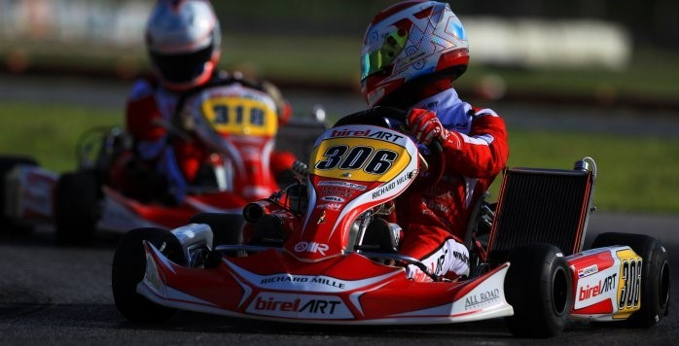

Fig-1.1

1. **Literature Review**

Brief History of Go-Kart

Go-kart technology has been widely developed since the introduction of wheels. But, it was not fully implemented in racing activity until the past three hundred years in America. The first go-kart was simply a cart consisting of wheels and handles jointed together as children pushed from behind when learning to walk or a four-wheeler platform where children where children can sit on it while another push the kart around.

Go-kart was invented in California by Art Ingels and Lou Borelli using 100cc mower engines and strong steel frames. Then, newly designed karts were beginning to gain popularity in Britian around the year 1959-1960. Go-kart has long existed in our world whether used in sport or recreation.

According to Graham Smith (2002), Art Ingels who was a veteran hot rod and race car builder at Kurtis Kraft in California, America invented the first ever go-kart in 1956. Initially, karting is a leisure motorsport enjoyed by airmen during the post-war period. The sport is quickly caught on with Go Kart Manufacturing Co. Inc. Being the first company to manufacture and distribute go-karts after two years. In 1959, McCullough also jump in the bandwagon of the industry, by becoming the first company to manufacture go-kart engines. Although go-kart originated from United States, it has also gain interests from countries all over the worlds especially Europe. For example, according to Tony Kart’s company profile in its website from Italy, they have been producing gokart since 1958 and emerged as one of the main manufacturer to date. Today, kart racing is governed by CIK-FIA which was founded in 1962 is the current primary international sanctioning body for kart racing. It is also a part of FIA since 2000 which is a governing body for motorsport across the globe. CIK-FIA plays an important role in regulating kart racing related matters such as technical regulations.

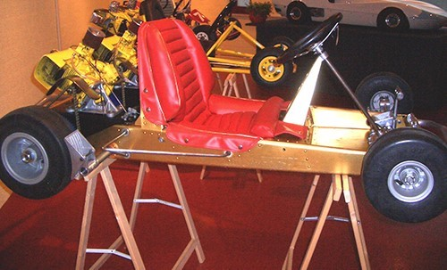

Fig-2.1

Rathman Exterminator, McCulloch MC10 2x (www.vintagekartscollection.com)

Main Components of Go-Kart

Chassis

The chassis of a go-kart or also known as the go-kart frame is like a foundation that attached to the axles and holds the engine of the go-kart. It is crucial to have a good design of chassis that will it gives the go-kart better traction for the driver to maneuver especially diving in corners at high speeds. Hence, according to Walker (2005), the absence of conventional suspension in go-kart compare to a normal vehicle requires the chassis itself to be flexible as a replacement of the suspensions. Yet, the go-kart chassis has to be rigid enough to withstand the strains it might experience such as weight of the drivers. In addition, a good traction from a proper design will also have less vibration which resulting a longer chassis life span.

For who takes karting seriously, they need a chassis that are able to suit different track conditions. Depending on the conditions of the track, a dry track will require a stiffer chassis; whereas a wet track will require a more flexible chassis. Therefore, there a chassis are designed to have removal stiffening bars on the rear, front, and side of the go-kart that can be removed or added depending on the track conditions.

There are four types of chassis which are caged, open, offset and straight chassis. A caged chassis have a roll cage that surrounds and protect the driver in an event of a roll-over. It usually used for karting on a dirt track where the terrain mostly uneven. As for open, offset and straight chassis, it does not have roll cage. Offset and straight chassis simply differentiate from each other based on the different position of the driver.

**Engines**

Typical go-kart will have two-stroke and four-stroke engines to choose from. By referring to Vortex’s engine specifications, a two-stroke engine usually produces power at range of 8hp single-cylinder unit to 90hp with a twin cylinder unit (Vortex, 2010). Whereas, four-strokes engine from manufacturer such as Aixro which can produces at maximum power up to 45hp (Aixro, 2010). Engine of a kart is also as important as the chassis as it drives the go-kart around the track.

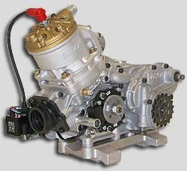

Fig-2.2 Vortex go-kart engine

#### **Transmission system**

#### 

Similar to any other transmission systems, by using gear ratios, it is important in order the conversion of power from engine to prop shaft. It consists of drive train, prop shaft, final drive shafts and whit or without gearbox and clutch, depending on the type of go-kart. However, there is no differential in a go-kart’s transmission system compare to conventional transmission especially in Karting World Championship which it is prohibited (CIK-FIA, 2010).

**Tyres**

Unlike vehicles tyres use on normal road to cater for different road conditions, go-kart has specific tyres for dry or wet track so that drivers can have maximum performances and grips from the tyres. Slick and wet tyres are two main types tyres used in karting. A slick tyre does not have grooves on the tyre. Slick tyre is used when the track is dry. On the other hand, wet tyres which are grooved are used in order to have more grips when the track is slippery. Hence, for track conditions that are in wet conditions, wet tyre will be employed.

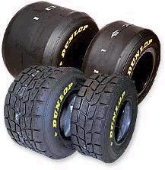

Fig-2.3 Different types of go kart tyres

1. **Methodology**

The SMITSONICS started with the process of brainstorming; literature review and continued with designing; design analysis; fabrication; assembly and documentation according to the standard specification of Go-kart.

We approached our design by considering all possible alternatives for a system and modeling them in CATIA V5. The model was then modified and retested for the final design. The design process of the vehicle is iterative and is based on various engineering and reverse engineering processes depending upon the availability, cost and other such factors. The design objectives, set out to be achieved were three simple goals applied to every component of the vehicle: durable, light-weight and high performance, to optimize the design by avoiding over designing, which would also help in reducing the cost, with this we had a view of our kart. This started our goal and we set up some parameters for our work,

* Frame design
* Steering system design
* Brake and wheels
* Drive train design
* Bodywork design
* Assembly of sub design
* Analysis of Design
* Body and composites
* Study of Engine
* Fabrication of Chassis
* Fabrication of Parts to Chassis
* Driving and Testing
* Calculation of actual parameters of Kart.
* Comparison of actual and design parameters.

We proceeded by setting up the budget for the project and worked to fabricate the entire kart in most economical way possible.

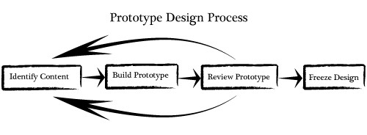

Fig-3.1 Methodology

**Design**

We approached our design by considering all possible alternatives for a system and modelling them in CATIA V5. The model was then modified and retested for the final design. The design process of the vehicle is iterative and is based on various engineering and reverse engineering processes depending upon the availability, cost and other such factors. The design objectives, set out to be achieved were three simple goals applied to every component of the vehicle: durable, light-weight and high performance, to optimize the design by avoiding over designing, which would also help in reducing the cost, with this we had a view of our kart. This started our goal and we set up some parameters for our work, distributed ourselves in groups. Sub- Teams for design

* + - Frame design
    - Body and composites
    - Steering system design
    - Brake and wheels
    - Drive train design
    - Bodywork design

The design section of this report is broken into three major topics-

* + - The design objectives
    - Considerations
    - Testing

We have used the steel tubular Ex. AISI 1020, AISI 4130, with a rigid cylindrical section having mass content of which is ≥ 5 % for the chassis design. The design is made with the robust material to meet the required stress caused on the extreme driving condition. All parts made from composite material are forbidden on the kart, except for the seat, the floor and the chain guard. The flexibility of the chassis frame corresponds to the elasticity limits of the tubular construction

Based on the overall objectives of the durability, performance and light weight design, the component is evaluated by the design team and must meet all of the criteria to become a part of the overall successful design alternatives were also considered during each process and testing commenced once the chosen design met the design objectives.

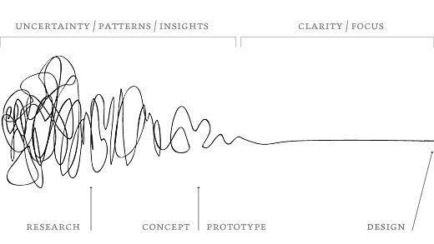

Fig- 3.2 Design Focus line

**Frame**

Frame Design

The chassis of go-kart is a skeleton frame made up of hollow pipes and other materials of different cross sections. The chassis of go-kart must be stable with high torsional rigidity, as well as it should have relatively high degree of flexibility as there is no suspension

The tube/rectangular pipe used in the fabrication of the chassis or the other frames/supports may be seam or seamless. Minimum cross section must be 1 inch (25.4mm), for pipe it will be OD and for rectangular section or square section it will be its minimum height. Material certification is essentially0 required to be produced during the technical inspection

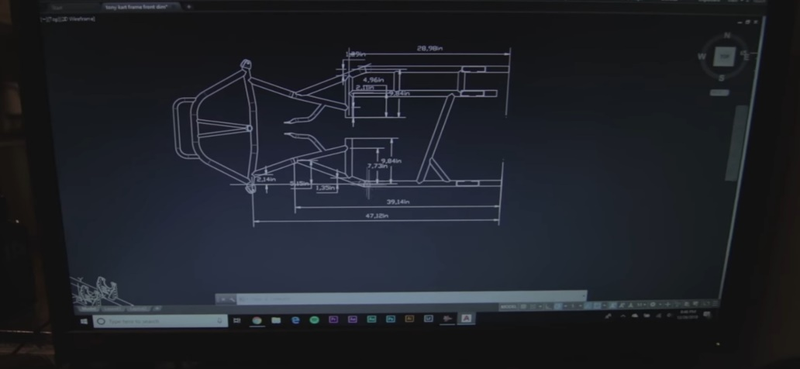

Fig-3.3

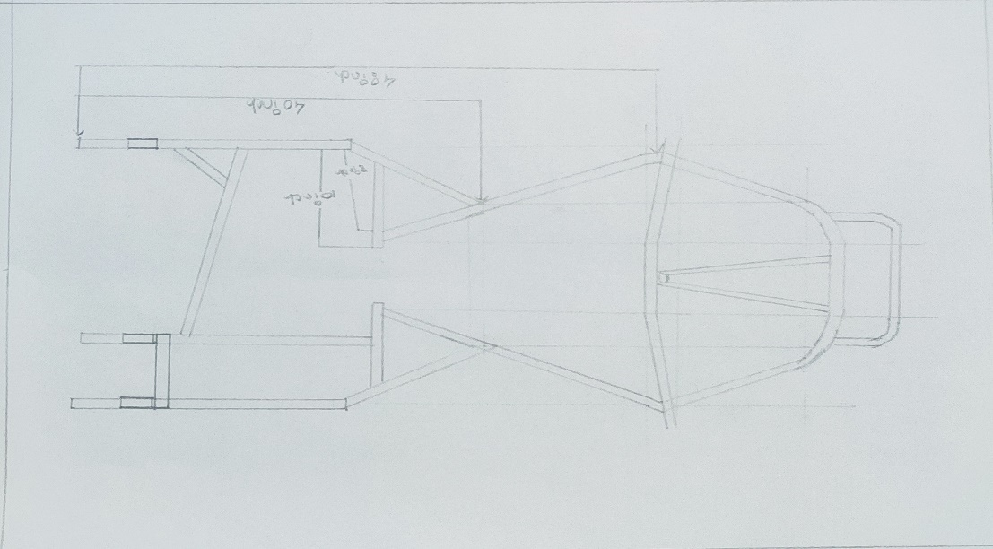

**Fig-3.4**

Design Objectives

The frame is designed to meet the technical requirements of competition the objective of the chassis is to encapsulate all components of the kart, including a driver, efficiently and safely. The chassis frame is the central and supporting part of the whole kart. It must be sufficiently resistant to be able to absorb the charges produced when the kart is in motion. Steel tubular construction with a cylindrical section is allowed. All the chassis main parts must be solidly attached to one another or to the chassis frame. A rigid construction is necessary, no articulations (mobile in 1, 2 or 3 axes). Articulated connections are only authorized for the conventional support of the steering knuckle and for steering. Any other device with the function of articulation in 1, 2 or 3 axes is forbidden. Any hydraulic or pneumatic absorbing device against oscillations is forbidden. No part may project beyond the quadrilateral formed by the front fairing, the rear wheel protection and the wheels.

Considerations

Frame design was first implemented by keeping in mind the safety requirement of the event. The first primary safety standard focused on during design was maintaining the proper clearance of the driver’s body rest to the other rigid parts like engine compartment and panel bracing of the vehicle. Once the basic requirements fulfilled the other safety design were implemented. The chassis was designed to give occupant extra space to operate the vehicle easily. The frame modal can be viewed as shown below:

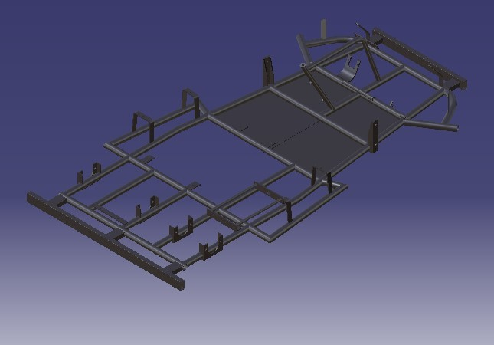

Fig-3.5 Chassis Design

|  |  |  |
| --- | --- | --- |
|  | **Chassis Description** | |
| **Properties** |  | **Value** |
| Area |  | 3.190 m2 |
| Volume |  | 0.006 m3 |
| Density |  | 7860.000 kg_m3 |
| Mass |  | 48.730 kg |

Table-3.1

The complete chassis design is done by using AISI 1020 pipes having 34 outer diameter and 2mm wall thickness. The pipes will meet the robust strength and toughness of the chassis design. The chemical composition is given by the table:

|  |  |  |
| --- | --- | --- |
|  | **AISI 1020 Chemical Composition** | |
| **Composition** |  | **Content (%)** |
| Iron(Fe) |  | 99.1 -99.5 |
| Manganese(Mn) |  | 0.3 – 0.6 |
| Carbon(C) |  | 0.18 -.0.23 |
| Sulphur(S) |  | 0 -0.05 |
| Phosphorus(P) |  | 0 -0.04 |

Table-3.2

### Testing and Calculations

The centre of gravity of the chassis alone is found using CATIA, and shown in following figure

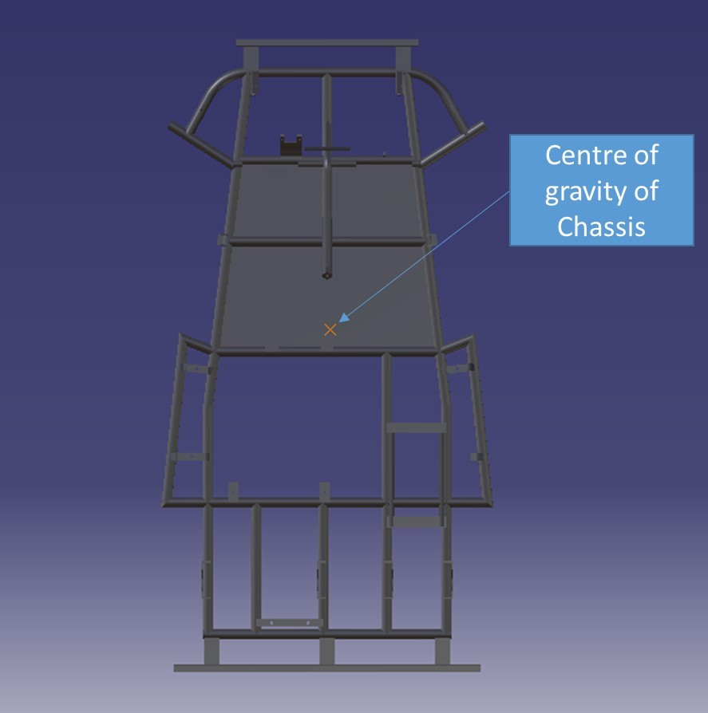

Fig-3.6 Centre of gravity of chassis

Keeping the frame as light as possible was a top priority. When power is limited, vehicle weight is a large factor in vehicle performance. The frame is one of the largest and heaviest components of the car, and which is why special attention was placed on the vehicle’s frame weight. The strategy utilized to minimize weight consisted of determining defined goals for the chassis and employing the correct material in the best places to accomplish those goals. Once baseline safety design requirements were met, FEA aided the material decision making process. FEA specifically helped to determine whether a member was under high or low stresses, in the scenarios discussed previously, making the chassis design process efficient and effective. Chassis members were made out of 2mm wall thickness and 34mm outer diameter AISI-1020. This material was chosen because of its weight reduction capability and beneficial material properties. Through accurately determining stresses on the chassis in different scenarios, weight reduction was able to be maximised through material selection and placement also the simplicity of the frame design that is use of less number of members tends to reduction in weight. The final weight of the chassis was measured on software is 48.730 kg and the gross (final) weight of the vehicle along with the driver is estimated to be 190 kg.

The FEA will compromise structural analysis such as static and impact analyses where the behaviors of the designed chassis under different conditions are reviewed. The severity of any undesirable results will be assessed and any necessary modification on the design will be made accordingly.

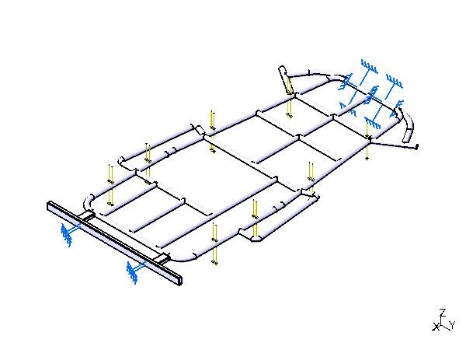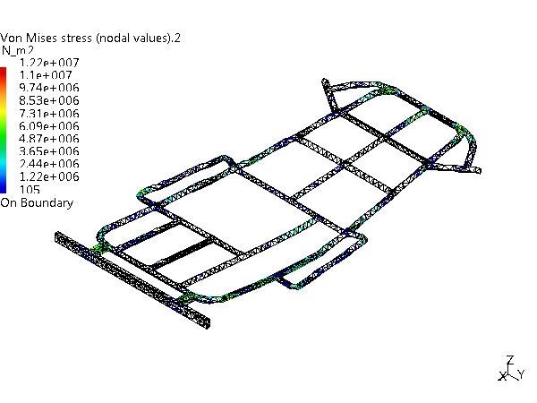

Fig-3.6 Static Analysis

Static analysis, static projection, and static scoring are terms for simplified analysis wherein the effect of an immediate change to a system is calculated without respect to the longer term response of the system to that change.

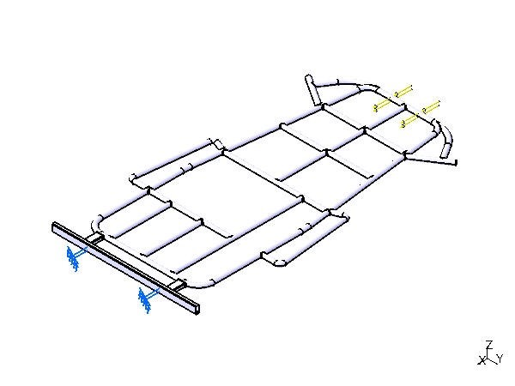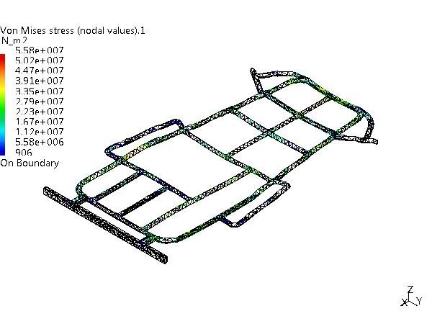

Fig- 3.7 Front Impact Analysis

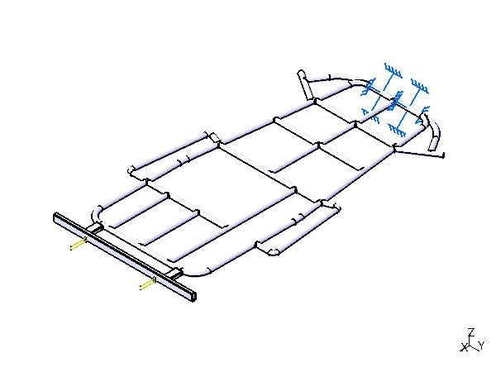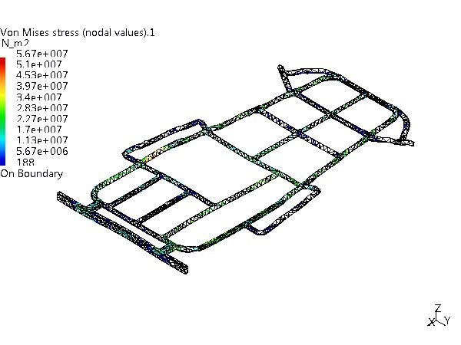

Fig-3.8 Rear Impact Analysis

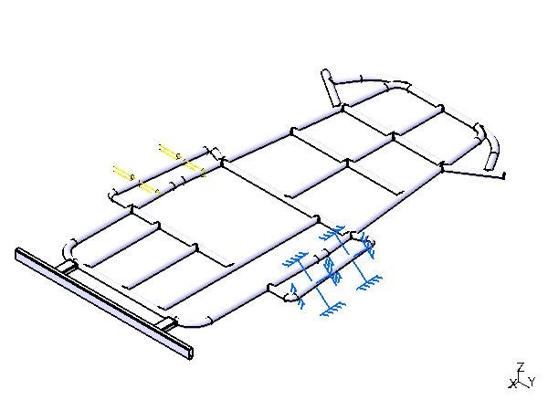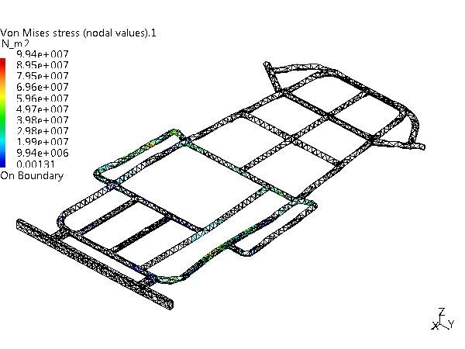

Fig-3.9 Left Side Impact

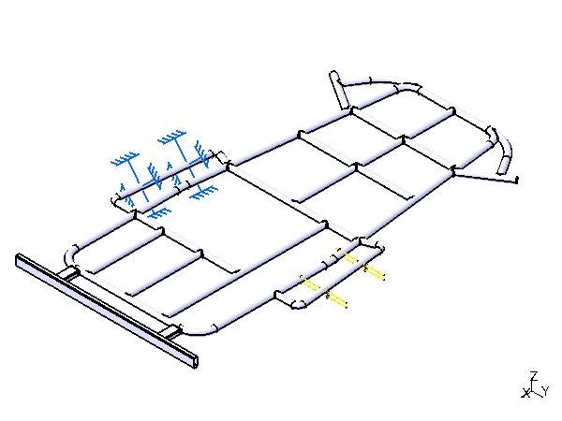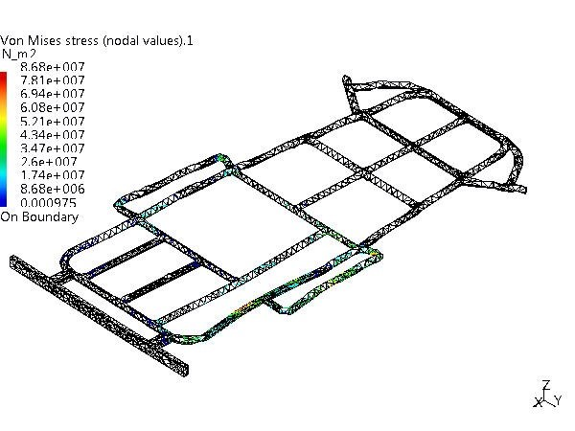

Fig-3.10 Right Side Impact

In structural analysis, forces and displacements are typically assumed to be applied slowly and the FEA is performed ‘quasi’ statically. However, if in practice a load is the result of an impact, such as a crash or drop test, the resulting stresses can be much higher as a result of shock waves propagating through the structure. Accurate assessment of these short-duration events is suited to FEA techniques.

Material properties are as follows:

|  |  |
| --- | --- |
| **AISI 1020 Material Properties** | |
| **Properties** | **Specification(Units)** |
| Base metal price | 1.6% relative |
| Density | 7.8gm/cm3(490Ib/ft3) |
| Elastic(Young’s, Tensile) Modulus | 210GPa(30x10E6 psi)) |
| Elongation at break | 18 -28 % |
| Specific Heat Capacity | 450J/Kg-k |
| Tensile Strength | UTS 420 -450MPa(61 to 65x103 psi)  Proof 230 -370MPa(33 to 54x103 psi) |

Table-3.3

The AISI 1020 steel structure has the property of low hardenability and low tensile carbon steel with Brinell hardness of 119, and tensile strength of 410790 MPa. It has high machinability, high strength, high ductility and good weld ability. It is normally used in turned and polished or cold drawn condition. Due to its low carbon content, it is resistant to induction hardening or flame hardening. Due to lack of alloying elements, it will not respond to nitriding. Core strength will remain as it has been supplied for all the sections. Alternatively, carbon nitriding can be performed, offering certain benefits over standard carburizing.

|  |  |  |  |  |  |  |
| --- | --- | --- | --- | --- | --- | --- |
| **Table 5.4 Maximum translational displacement and Factor of Safety Calculation** | | | | | | |
| **Type of**  **Test** | **Acc.** | **Load**  **(N)** | **Impulse**  **Time** | **Max.**  **Translational**  **Disp. (mm)** | **Max. Von**  **Mises**  **Stress**  **(N/mm2)** | **FOS** |
| Static Test | - | 1000 | - | 0.146 | 12.2 | 20.49 |
| Front  Impact | 4g | 8000 | 0.42 s | 0.289 | 55.8 | 4.48 |
| Rear  Impact | 4g | 8000 | 0.42 s | 0.285 | 56.7 | 4.40 |
| Left Side Impact | 2g | 4000 | 0.83 s | 0.709 | 99.4 | 2.51 |
| Right  Impact  Test | 2g | 4000 | 0.83 s | 0.586 | 86.8 | 2.88 |

Table-3.4

AISI 1020 steel can be largely utilized in all industrial sectors in order to enhance weld ability or machinability properties. It is used in a variety of applications due to its cold drawn or turned and polished finish property.

Let us consider

Velocity = 16.67 m/s

Yield Strength of steel = 250 N/mm2

Mass of the vehicle = 200 kg

Then

Force = Mass of Vehicle * Acc.

Impulse Time = Mass of vehicle * (Velocity / Load)

FOS= Yield strength of steel / Max. Von Mises Stress

The values of Maximum Von Mises stresses and Maximum translational displacements can be obtained from the results of above analyses.

Here FOS 20.49 for static analysis and 4.48, 4.40, 2.51 and 2.88 for impact analysis results that designed chassis is safe and the considerations are correct.

# Steering System

Steering System

The steering system must be able to control (simultaneously) at least two (2) wheels. The steering system must have positive steering stops that prevent the steering linkages from locking up either in RH or LH turning

Toe angle

Toe angle is the angle that a wheels makes with a line drawn parallel to the length of the car when viewed from above

Negative and positive toe angle

1)Toe in

2)Toe out

3)Neutral

We used neutral steering system in go-kart

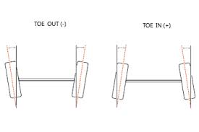

Fig-4.1

Design Objectives

The steering system is designed to withstand the stress of safely maneuvering the vehicle through any type of possible condition at the time of driving. The purpose of the steering system is to provide directional control of the vehicle with minimum input. The main goal for steering radius of 4m or less and have 100% Ackerman steering.

Steering system must be controlled by a steering wheel which a continuous rim not incorporating any reflex angles in its basic shape. The upper and lower 1/3 of the circumference may be straight or of a different radius to the rest of the wheel. The rim must be manufactured with a metallic structure made of steel or aluminum. Any device mounted on the steering wheel must not protrude by more than 20 mm from the plane forward of the steering wheel and must not have sharp edges. Flexible steering controls by cable or chain are forbidden. All parts of the steering must have a method of attachment offering maximum safety (split pins, selflocking nuts or burred bolts). The steering column must have a minimum diameter of 18 mm and a minimum wall thickness of 1.8 mm. It must be mounted with a safety clip system for the lower bearing restraint nut. The steering column must be made of steel.

. 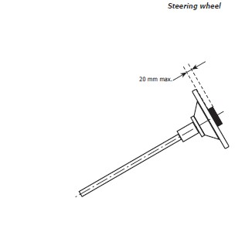

Fig-4.2 Steering Specifications

Considerations

Simplicity and safety were the main design specifications for the vehicle’s steering system. While designing the steering system the constraints that we possessed were center alignment of steering system track width, human effort at the steering wheel and the desired response of the steering system. A pivot pin steering arrangement was chosen due to its light weight, simple design and low cost. Very less play due to limited number of joints.

The steering knuckles system is where the axles themselves, which are mounted on a knuckles, out and away from the go kart, and they actually rotate around these pivots, and cause the wheels to turn.

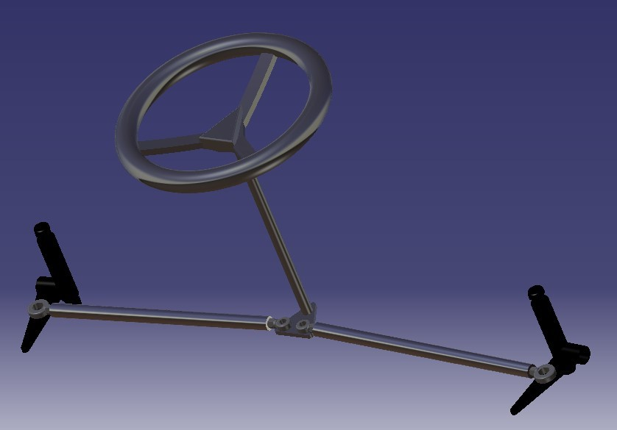

Fig-4.3

Steering knuckle system

Testing and Calculations

If we consider these links as four bar link mechanism, having one link fixed, then the mean position of the tire ( while going straight ) is shown as follows

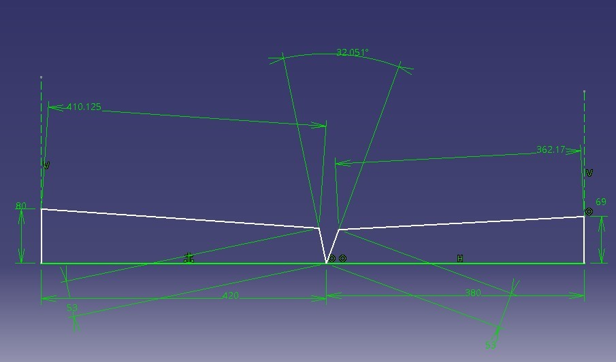

Fig-4.4 Mean Positions of tires

While taking a left turn maximum steering angle is calculated in following figure:

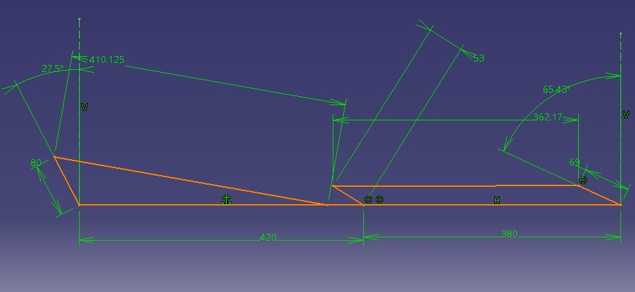

Fig-4.5 Maximum Left turn

Also while taking a right turn maximum steering angle is calculated as follows:

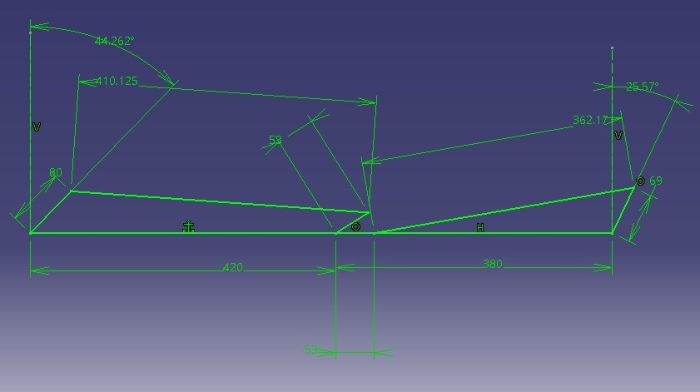

Fig-4.6 Maximum Right turn

Therefore, maximum steering angle for left wheel is 65.43 degrees while taking left turn and 25.57 degrees while taking a right turn. Similarly maximum steering angle for right wheel is 27.5 degrees while taking left turn and 44.262 degrees while taking a right turn. These differences between the maximum steering angles are present because seat is not aligned at centerline. Also steering wheel is also aligned with seat for better grip to the driver. Therefore the left pushrod is smaller than the right pushrod. The kart is having very small turning radius. Stoppers are welded besides the steering rod to restrict its motion beyond front semicircular region.

The turning radius depends on two things:

Wheelbase w, which is the distance between the front and the rear wheel

Angle α of the front wheel

We suppose that only the front wheel is able to turn.

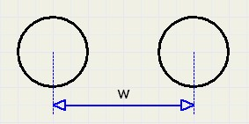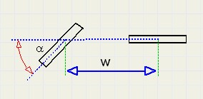

Fig-4.7 Calculation of Wheelbase

The front and rear wheel follow a circle with the same centre. At all times, the direction is perpendicular to the radius.

See figure below:

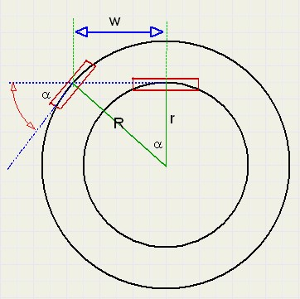

Fig-4.8 Calculation of turning radius

The radius of the front wheel is R, the rear wheel r.

From the figure above we conclude:

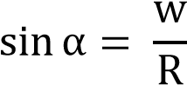

We have wheelbase (w) = 109cm

And α = 39.0543 degrees

Then turning radius (R) = 173 cm = 1.73 m

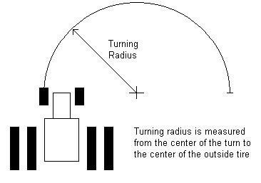

Fig-4.9 Furning Radius

1. **Axle**

Design Considerations

Go karts use a variety of rear axle types. The most common are single wheel drive, but two wheel drive karts are also popular. The simplest of these is the live axle, and the more complicated use a differential. A live axle means that the wheels are mounted directly to the axle, and the axle spins. A dead axle would be where the wheels spin freely and the axle does not turn.

Live Axle for traction

* + - 1. live axle on a go kart means that the engine will power both rear wheels at the same speed and power. This is accomplished with a single sprocket mounted to the live axle. Since both wheels are locked in to the power all the time, off road go karts often use a live axle. When both wheels are turning at the same time, you'll have twice the traction. This is great for sand, loose dirt, etc, where a single wheel would often spin out.

This is not to say that live axles don't have their drawbacks. Unfortunately for the onroad set, a live axle means that turning is difficult. This is because both rear wheels turn at the exact same speed.

When making a turn, the outside wheel must be able to spin faster than the inside wheel. If they are forced to turn at the same rate by a live axle, then the outside wheel must slip on the driving surface in order to turn as fast as needed.

That's easily accomplished on dirt and sand; the outside wheel can slip without problem. But on hard dirt and roads, the wheels have much more traction, and therefore it's harder for that wheel to slip.

Differentials

* + - 1. more complicated solution to this problem is to use a differential on the rear axle, just like a car has. This allows both wheels to be powered, and allows for easy cornering. However, it's not the best solution for serious off road. This is because when traction is lost on one wheel, it will spin and the other won't turn at all, effectively giving you a single-wheel drive. These systems are readily available for less than $100.

Single Wheel Drive (Fixed Axle)

If you plan to use the kart for serious off road, then a live axle is the way to go. But for hard-pack and asphalt, you can't beat a single wheel drive for the price. A single wheel drive runs a chain from the engine clutch straight to the drive wheel, which has a sprocket mounted directly to it. The other rear wheel is left to spin free-wheel. A single wheel drive is by far the easier and cheaper than a differential, and give you the needed slip for on-road and hard pack dirt driving. Many parts houses sell complete assemblies that have the rear wheel, sprocket, and brake as one. This will save you some cash and simplify the need to match bolt hole patterns for independently purchased pieces.

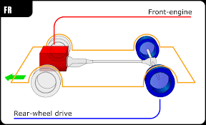

Fig-5.1

Tandem Axle

With a tandem axle, there are multiple axles located in relatively close proximity to each other. The purpose of this design is to increase the weight capacity of the vehicle and is most commonly used on large trucks.

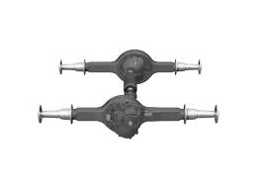

Fig-5.2

Considerations

One of the innovations used in our go kart, has been the use of split axle for transmission. This has not only allowed us to have the effect of a pseudo differential, but has enhanced the car’s traction and grip on the road. A single wheel drive runs a chain from the engine clutch straight to the drive wheel, which has a sprocket mounted directly to it (right wheel). The other rear wheel is left to spin free-wheel (left wheel).A single wheel drive is by far the easier and cheaper than a differential, and give you the needed slip for on-road and hard pack dirt driving. In a split[-axle design,](http://www.wisegeek.com/what-are-the-different-types-of-axle-design.htm) each wheel is attached to a separate shaft. The purpose of this split is to provide a fixed position for the wheel, but also to allow each wheel to move independently of the other. This type is used on passenger cars.

Testing and calculations

The innovation of split axle or dual axle can be used universally at all temperatures, weather conditions and pavement conditions as provided by the Caltrans’ Pavement Condition Survey Manual or the Maintenance Technical Advisory Guide.

1. **Drive Train**

Design Objectives

The design objective of drive train depends on followings points

1. Purpose of drivetrain
2. Types of wheels
3. Comparison of drivetrain strengths and weaknesses
4. Resources and needs
5. Which drive train is best for you?
6. According to specifications of power train consists of:

Engine

Power is transmitted from the engine to the rear axle by way of a chain (some rentals use a belt).

* + - * 4-stroke engines can be standard air-cooled industrial based engines, sometimes with small modifications, developing from about 5 to 20 hp. Briggs & Stratton, Tecumseh, Kohler, Robin, and Honda are manufacturers of such engines. They are adequate for racing and fun kart applications. There are also more powerful four-stroke engines available from manufacturers like Yamaha, KTM, Biland, or Aixro (Wankel engine) offering from 15 hp up to 48 hp. They run to and around 11,000 rpm, and are manufactured specifically for karting. PRD makes the PRD Fireball, a two-stroke engine delivering 28.5 hp at 15,580 rpm. Indoor Go karts vary in size from 160cc to 270cc and are normally ran on the Honda GX range used in lawnmower engines.
      * Electric go-karts are low maintenance, requiring only that the lead-acid batteries of the cars be plugged into an array of chargers after each run. Since they are pollution-free and emit no smoke, the racetracks can be indoors in controlled environments. Most fully charged electric karts can run a maximum of 20 minutes before performance is affected. Some karts have been fitted with hydrogen fuel cells.

Engine Mounting

During most of the test runs, the vehicle had the problem of unwanted chain slagging. So to rectify this, measures should be taken.

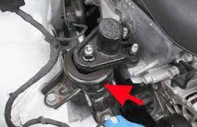

Fig-6.1

Chain and sprocket

In the case of go-kart chains, it is possible to modify the overall gear ratio of the chain drive by varying the diameter (and therefore, the tooth count) of the sprockets on each side of the chain. This is the basis of derailleur gears. A multi-speed g-kart, by providing two or three different-sized driving sprockets and up to 11 (as of 2014) different-sized driven sprockets, allows up to 33 different gear ratios. The resulting lower gear ratios make the bike easier to pedal up hills while the higher gear ratios make the bike more powerful to pedal on flats and downhill. In a similar way, manually changing the sprockets on a motorcycle can change the characteristics of acceleration and top speed by modifying the final drive gear ratio.

Transmission

Transmission should always be to the rear wheels. The method and type is free but any type of differential, whether through the axle, the wheel mounting hub or by any other means, is prohibited.

Muffler and Exhaust

Concept of Go-Green should be kept in mind while selecting the appropriate exhaust system. In order to reduce the noise, efficient exhaust silencers are compulsory. The exhaust system shall discharge behind the Driver and shall not operate at a height of more than 45 cm from the ground. The exhaust silencer outlet, the external diameter of which must be more than 3 cm. It is forbidden for the exhaust in any way to pass forward and across the plane in which the Driver is seated in his normal driving position. The noise limit in force is 108 dB maximum, including all tolerances and the influence of the environment.

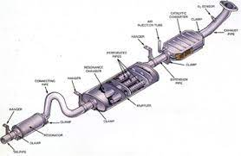

Fig-6.2

Considerations

Engine

We had two choices for engines

|  |  |  |
| --- | --- | --- |
| **Comparison between Suzuki Access 125 and Recoil 550 Series Engines** | | |
| **Engine** | **Suzuki Access 125** | **Recoil 550 Series**  **Model-83100** |
| Displacement(cc) | 125 | 127 |
| Type | 4 Stroke, Single Cylinder,  OHC | 4 Stroke ,Single Cylinder,  OHC |
| Power | 6.4 Kw@7000RPM  (8.58Hp@7,000RPM) | 5.5 Kw@3600RPM  (7.37Hp@3600RPM) |
| Cooling System | Air cooled | Air cooled |
| Max Torque | 9.8Nm@5000rpm | 7.45Nm@3200 RPM |
| Transmission | CVT | - |
| Ignition | Self and kick | Electronic |
| Weight | 60 Kg | 16 Kg |
| Bore | 53.5 mm | 62 mm |
| Stroke | 55.5 mm | 42 mm |
| Warranty | 2 year or 24000 km | 2 years consumer use / 1 year commercial use |
| Fuel type | Gasoline | Gasoline |

Table-6.1

The engine installed is 550 Series Engine (3.5 HP)

|  |  |
| --- | --- |
| **Engine Specifications** | |
| Type | Recoil 550 Series Gasoline Single cylinder Air Cooled Mid-duty chore applications |
| Displacement | 127 cm3 |
| Dimensions | 13in. × 15in. × 13 in. |
| Max. Torque | 5.5 ft./lbs. |
| Ship Weight | 14 kg |
| Max. RPM | 3300 |
| Bore × Stroke | 2.44in. × 1.65in. |

Table-6.2

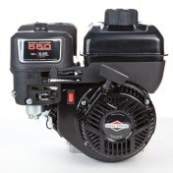

Fig-6.3

Engine Mounting

Engine mounting is of flexible type. Any go kart engine can be mounted on the go kart, irrespective of its size and power. Most of the time, the chain length may vary due to external factors such as temperature changes, dragging of the chain or a loose sprocket. Usage of this mechanism allows us to tighten or loosen the chain easily. Since the tray is directly attached to the chassis, the engine load is evenly distributed. This flexible mounting consists of a metal tray directly attached to the chassis on which the engine is mounted. The position of the tray can be changed by adjusting the nut bolt mechanism present in it. During most of the test runs, the vehicle had the problem of unwanted chain slagging. So to rectify this, this mechanism was introduced.

Chain and sprocket

Good quality chain and sprockets are used to ensure that chain does not loosen down due to temperature changes. Number of teeth on axle sprocket is 24 and number of teeth on engine sprocket is 18.

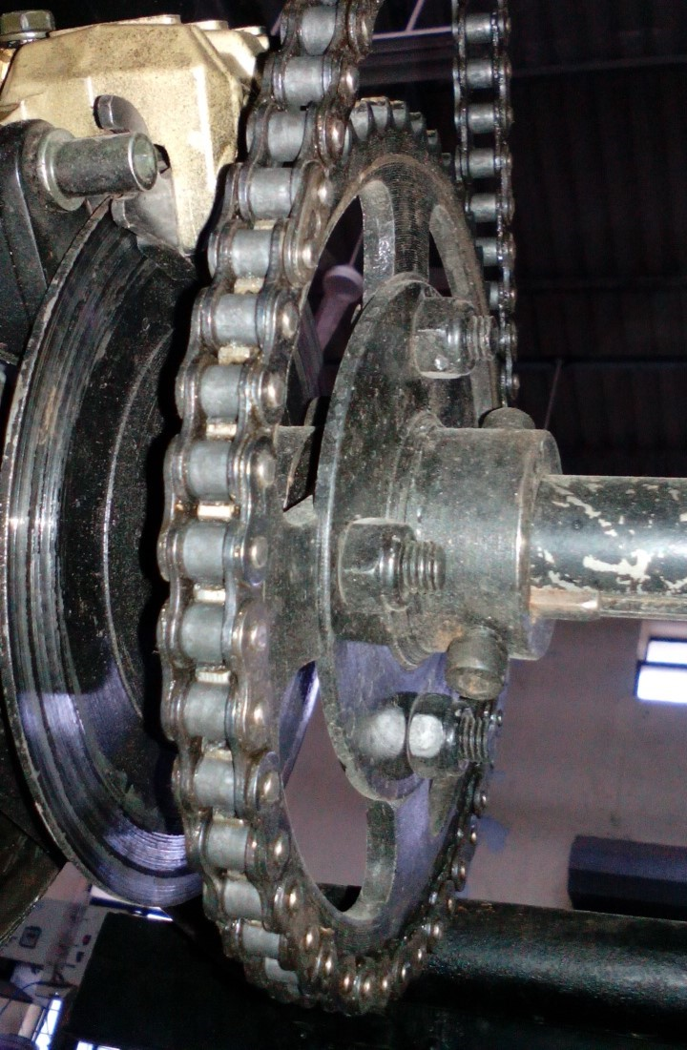

Fig-6.4 Chain and sprocket

Transmission

The transmission is rear wheel, having single wheel drive (dual axle). A single wheel drive runs a chain from the engine clutch straight to the drive wheel, which has a sprocket mounted directly to it. The other rear wheel is left to spin free-wheel. A single wheel drive is by far the easier and cheaper than a differential, and give you the needed slip for on-road and hard pack dirt driving.

Muffler and Exhaust

The concept of Go-Green is used and appropriate exhaust silencer is used to reduce the noise below 108 Db/A. The maximum height of the silencer is 44cm having 7cm external diameter of outlet.

Testing

For chain and sprocket Let us consider

Optimal Engine rpm (N2) = 2700 rpm = 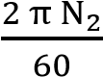 rad/s = 282.7433 rad/s

Diameter of rear tire = 11 inches

Radius of rear tire (R) = 5.5 inches = 5.5× 2.54 cm = 13.97 cm = 1.397 m

Required speed of kart (v) = 80 km/h = 288 m/s

Required axle rotational speed (N1) =  rad/s = 209.156 rad/s

Velocity ratio = 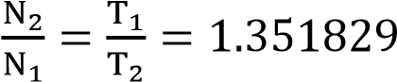

Where T1 = Numbers of teeth on axle sprocket and T2 = Numbers of teeth on engine sprocket. If number of teeth on axle sprocket is considered to be 24. Then

T2 = 17.7~ 18 teeth

1. **Electric motor**

Due to low inertia, BLDC motors have faster acceleration. BLDC motors have less weight. They can run at high speed than a conventional DC motor They have many advantages like low cost, simplicity, reliability, good performance, long life.

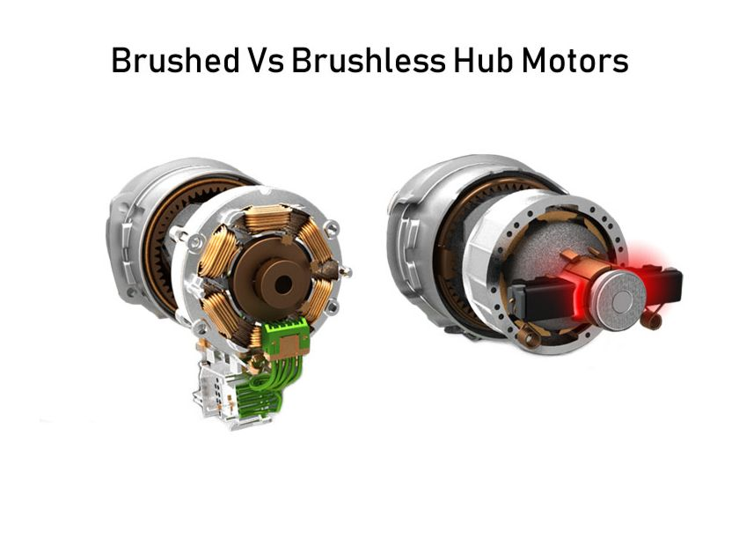

Fig-7.1

We used Electric go kart motor BLDC motor, rated current: 42A A Brushless DC motors require less maintenance The considerable power output of 2000W ensures its high working efficiency. Voltage: DC 48 V.

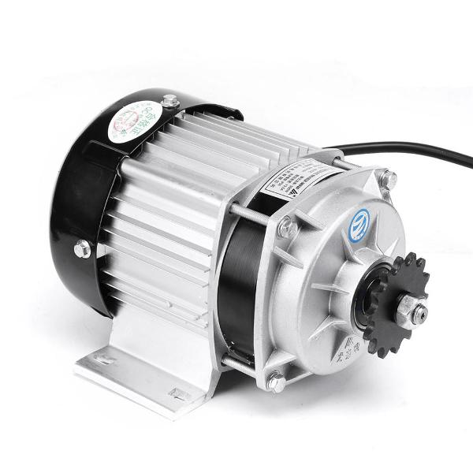

Fig-7.2

**About Battery**

Batteries are a collection of one or more cells whose chemical reactions create a flow of electrons in a circuit. All batteries are made up of three basic component an anode (the ‘–’side ) a cathode (the ‘+’ side) and some kind of electrolyte (a substance that chemically reacts with the anode and cathodes)

We used 12v+12v=24v battery in go-kart

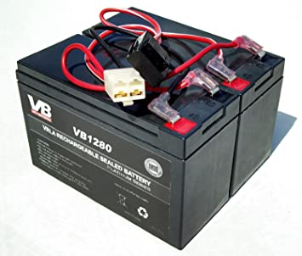

Fig-7.3

**Lithium-ion battery**

Batteries used in EV are generally lithium-ion based batteries because they offers a very high volumetric energy density and the energy to weight ratio is also high.

They can be recharged again and again for over a large number of times without any effect on the healthy of battery

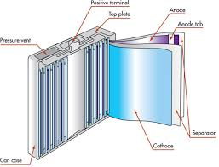

Fig-7.4

1. **Brakes and Wheels**

Braking System

Brakes are essentially a mechanism to change energy forms. When you are travelling at speeds your vehicle has kinetic energy. When you apply the brakes the pads or shoes that press against the brake drum or rotor convert that energy into thermal energy via friction

Types of brakes

1)Drum

2)Disc brake

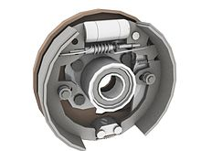 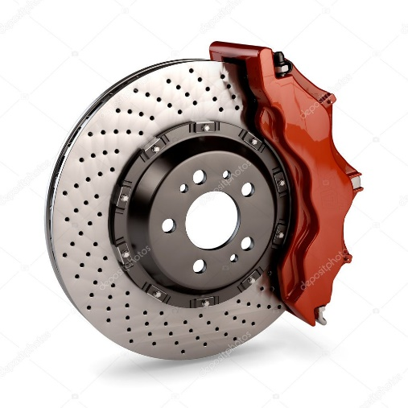

Fig-8.1

We used disc brake in go-kart

Speed Controller

The controller or electronic speed controller (ESC) is an electronic circuit that controls the speed of the motor in an electric scooter. It receives input from the throttle and precisely controls the flow of current from the battery to the motor. For most scooters, the controller also provides regenerative braking capabilities.

Types of speed controller

1) 250v (scooter)

2) 350v (bike) or (go-kart)

3) 650v (electric sport bike)

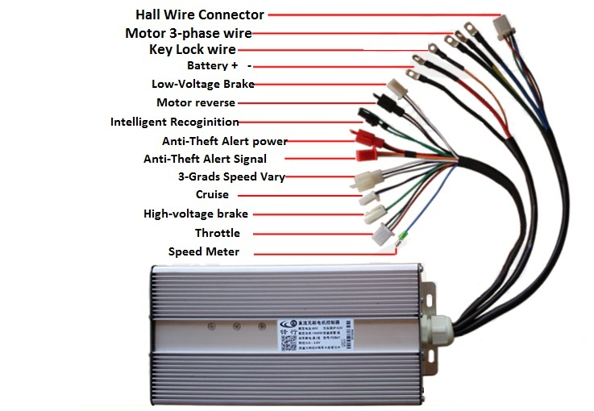

Fig-8.2

**Important keys in speed controller**

1. Battery
2. Motor
3. Throttle
4. Power lock (ignition)
5. Brake light
6. Indicator lights
7. Brake

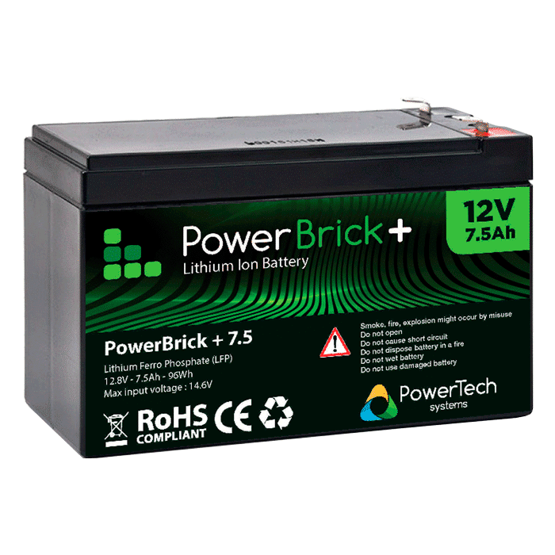

Fig-8.3

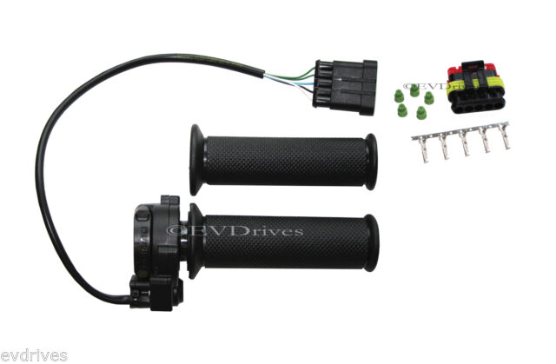 Fig-8.4

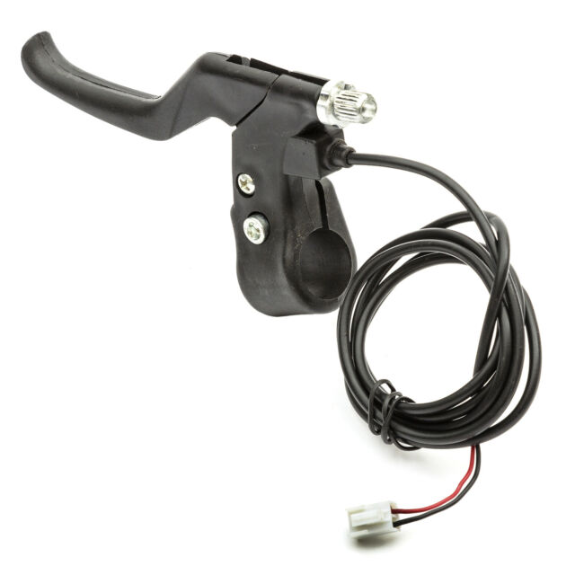 Fig-8.5

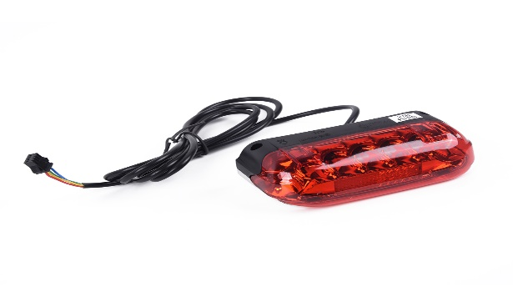 Fig-8.6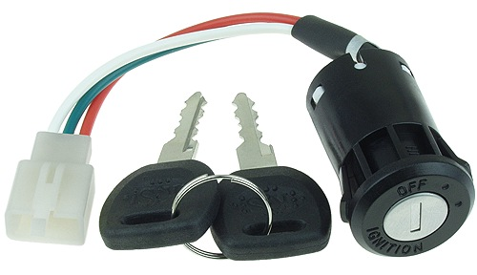

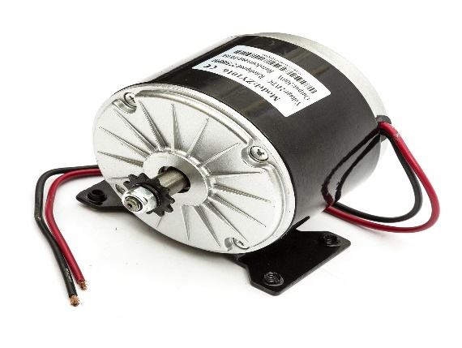 Fig-8.7 

* 1. Design Objectives

The vehicle must be equipped with a braking system that is operated by a single control. Rear braking is only allowed. “Brake-by-wire” systems are prohibited. Braking fluid should be preferably DOT-3 or DOT-5. The brake control [the link between the pedal and the pump(s)] must be doubled (if a cable is used, it must have a minimum Ø of 1.8 mm and be blocked with a cable clip of the flat clip type). Brake discs must be mandatorily be made from steel, stainless steel or cast iron.

Everybody can use tires of their choice. The rims must be fitted with pneumatic tires (with or without tubes). The number of wheels is set at four. Only the tires may come in contact with the ground when the Driver is on board. By set of tires is meant 2 front tires and 2 rear tires. The simultaneous use of tires of different makes or of “slick” and “wet weather” tires on a kart can be used. The attachment of the wheels to the axles must incorporate a safety locking system (such as split pins or self-locking nuts, circlips, etc.). The use of rims complying with the technical drawing appended is compulsory:

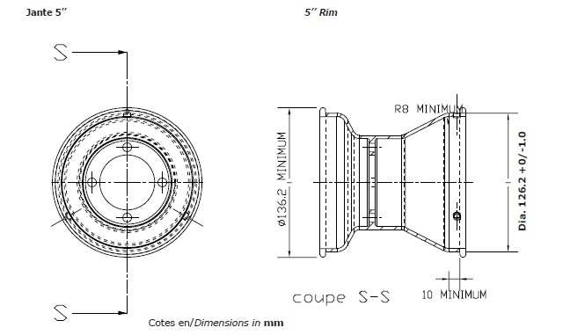

Fig-8.9 Rim Specification

* + - * Coupling diameter of the tire for 5-inch rims: 126.2mm with a +0/-1 mm tolerance for hump rim diameters and for screw-type rim diameters.
      * Width of the tire housing: 10 mm minimum.
      * External diameter for 5 inch rims: 136.2 mm minimum.
      * Radius to facilitate the balance of the tire in its housing: 8 mm.
      * Maximum pressure for assembly: 4 Bar.
      * Tire burst resistance test with fluid at an 8 Bar Pressure.

This rim must be manufactured in accordance with the technical drawing

Tires should be 5” internal diameter. The maximum exterior diameter of the front wheel is 280 mm and of rear wheel is 300 mm. The maximum width of rear wheel is 215mm and maximum width of front wheel is 135mm.

* 1. Considerations

The best of the braking solutions, a disc brake is a high tech advancement in go karting. They provide superior stopping power, even when wet. Prayaas is equipped with hydraulic dual disc brakes with braking fluid DOT-4.DOT 3, DOT 4 and DOT 5.1 are polyethylene glycolbased fluid (contrasted with DOT 5, which is silicone-based). Fluids such as DOT 3 are hygroscopic and will absorb water from the atmosphere. This degrades the fluid's performance, and if allowed to accumulate over a period of time, can drastically reduce its boiling point. In a passenger car this is not much of an issue, but can be of serious concern in racecars or motorcycles. DOT3 has been all but replaced with the superior DOT4 as there is little cost difference between the two. Diameter of brake cable is 5mm. Brake discs are made of stainless steel.

Traxter tubeless tires with max inflation 4kg/cm2 are used.

|  |  |  |  |
| --- | --- | --- | --- |
|  | **Tire specificatons** | |  |
| **Front tire** |  | **Rear tire** |  |
| Ext. Diameter | 10” | Ext. Diameter | 11” |
| Width | 4.50” | Width | 7.10” |
| Inner Dia. | 5” | Inner Dia. | 5” |

Table-8.1

1. Bodywork

Non-metallic; carbon fiber, Kevlar and glass fiber are allowed only in case of Super karts. We have used glass fiber materials for designing of the bumpers considering exceptionally that it shall not have any sharp angles as a result of a possible breakage and splintering it. Fiber Glass is used in the front, side and rear bumpers and the driver’s seat considering there is no sharp edges and with a sturdy look. There is no angle of splintering of the fibre glass from any sides which can cause any accidental damage .The thickness of the fibre glass is 2.5mm.

Manufacturing rules

1. Visibility Requirements
2. Path for wires and pipes
3. Pipe Bending
4. Pipe Joint

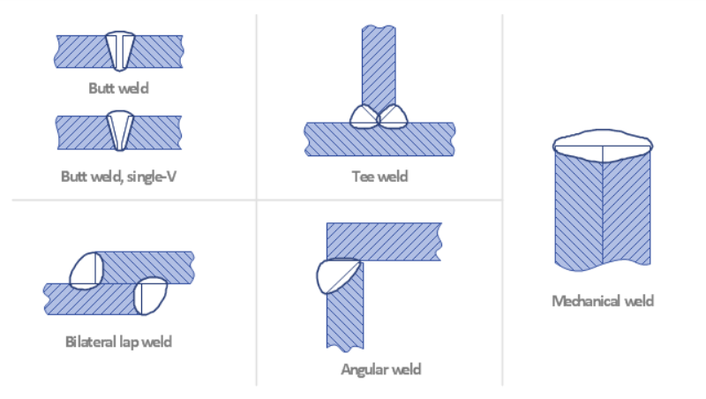

Fig-9.1

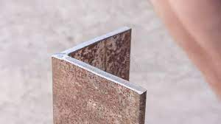

Fig-9.2

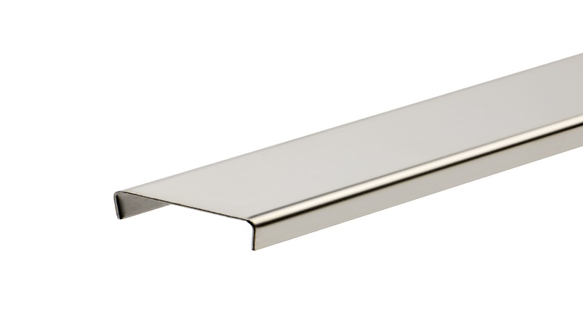

Fig-9.3

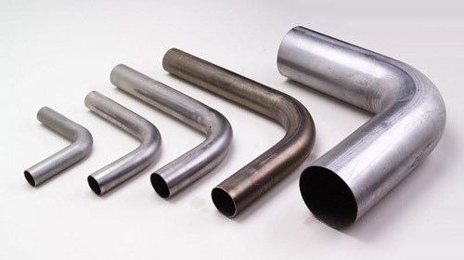

Fig-9.4

1. No sharp edges

Fibre-reinforced plastic (FRP)

FRP (also fibre-reinforced polymer) is a composite material made of a polymer matrix reinforced with fibers. The fibres are usually glass, carbon, aramid, or basalt. Rarely, other fibres such as paper or wood or asbestos have been used. The polymer is usually an epoxy, vinylester or polyester thermosetting plastic, and phenol formaldehyde resins are still in use. FRPs are commonly used in the aerospace, automotive, marine, construction industries and ballistic armor.

A polymer is generally manufactured by Step-growth polymerization or addition polymerization. When combined with various agents to enhance or in any way alter the material properties of polymers the result is referred to as a plastic.. Fibre-reinforced plastics are a category of composite plastics that specifically use fibre materials to mechanically enhance the strength and elasticity of plastics.

Advantages and limitations

FRP allows the alignment of the glass fibres of thermoplastics to suit specific design programs. Specifying the orientation of reinforcing fibres can increase the strength and resistance to deformation of the polymer. Glass reinforced polymers are strongest and most resistive to deforming forces when the polymers fibres are parallel to the force being exerted, and are weakest when the fibres are perpendicular. Thus this ability is at once either an advantage or a limitation depending on the context of use. Weak spots of perpendicular fibres can be used for natural hinges and connections, but can also lead to material failure when production processes fail to properly orient the fibres parallel to expected forces. When forces are exerted perpendicular to the orientation of fibres the strength and elasticity of the polymer is less than the matrix alone. In cast resin components made of glass reinforced polymers such as UP and EP, the orientation of fibres can be oriented in two-dimensional and threedimensional weaves. This means that when forces are possibly perpendicular to one orientation, they are parallel to another orientation; this eliminates the potential for weak spots in the polymer.

Failure modes

Structural failure can occur in FRP materials when:

1. Tensile forces stretch the matrix more than the fibres, causing the material to shear at the interface between matrix and fibres.
2. Tensile forces near the end of the fibres exceed the tolerances of the matrix, separating the fibres from the matrix.
3. Tensile forces can also exceed the tolerances of the fibres causing the fibres themselves to fracture leading to material failure.

Design considerations

FRP is used in designs that require a measure of strength or modulus of elasticity that nonreinforced plastics and other material choices are either ill suited for mechanically or economically.

Manufactured Fibre Parts

It is mandatory to use the body work.

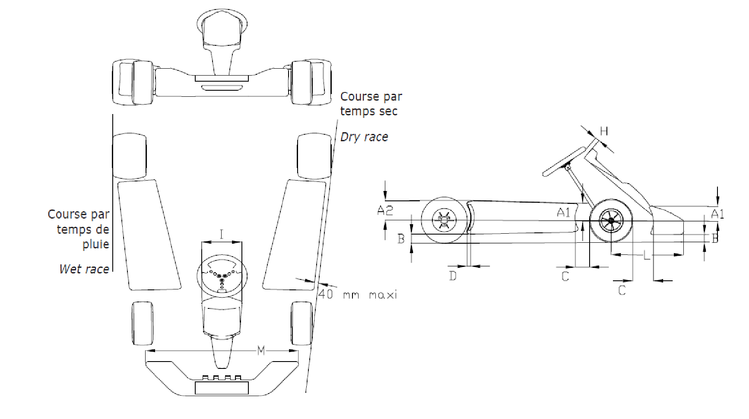

Fig-9.5 Bodywork Specification

The bodywork is made up of all parts of the kart that are in contact with air, other than mechanical parts, the fuel tank and number plates. The bodywork must be impeccably finished, in no way of a make-shift nature and without any sharp angles. The minimum radius of any angles or corners is 5 mm. It must be made up of two side bodyworks, one front fairing, one front panel and one possible rear wheel protection. No element of the bodywork may be used as fuel tank. No cutting of bodywork elements is allowed. They must under no circumstances be located either above the plane through the top of the front and rear tires or beyond the plane through the external part of the front and rear wheels (with the front wheels in the straight ahead position). In the case of a “Wet race”, side bodywork may not be located outside the plane passing through the outer edge of the rear wheels. They may not be located inside the vertical plane through the two external edges of the wheels (with the front wheels in the straight ahead position) by more than 40 mm. They must have a ground clearance of 25 mm minimum and of 60 mm maximum. The surface of the side bodyworks must be uniform and smooth; it must not comprise holes or cuttings other than those necessary for their attachment. Gap between the front of the side bodyworks and the front wheels: 150 mm maximum. Gap between the back of the side bodyworks and the rear wheels: 60 mm maximum. No part of the side bodyworks may cover any part of the Driver seated in his normal driving position. The side bodyworks must not overlap the chassis-frame seen from underneath. On their outer side they must comprise a vertical surface (with a tolerance of +/- 5° in relation to the theoretical vertical plane) with a minimum height of 100 mm and a minimum length of 400 mm located immediately above the ground clearance. They must not be able to hold back water, gravel or any other substance. They must be solidly attached to the side bumpers. On their rear vertical surface close to the wheels there must be a space for competition numbers.

Front Fairing

It may under no circumstances be located above the plane through the top of the front wheels. It must not comprise any sharp edges. Its minimum width is 1,000 mm and its maximum width is the external width of the front wheel/axle unit. Maximum gap between the front wheels and the back of the fairing: 150 mm. Front overhang: 650 mm maximum.

The fairing must comprise on its front side a vertical surface (with a tolerance of +/- 5° in relation to the theoretical vertical plane) with a minimum height of 80 mm and a minimum length of 300 mm located immediately above the ground clearance. The fairing must not be able to hold back water, gravel or any other substance

Front panel

It must not be located above the horizontal plane through the top of the steering wheel. It must allow a gap of at least 50 mm between it and the steering wheel and it must not protrude beyond the front fairing. It must neither impede the normal functioning of the pedals nor cover any part of the feet in the normal driving position. Its width is 250 mm minimum and 300 mm maximum. Its lower part must be solidly attached to the front part of the chassis-frame directly or indirectly. Its top part must be solidly attached to the steering column support with one or several independent bar(s). A space for competition numbers must be provided for on the front panel.

Side Fairing

The side fairing must be made of hollow plastic molded and must not present any danger as regards safety. Furthermore, the structure must be molded plastic without foam filling, and the wall thickness must be constant in order to provide uniform strength. It may under no circumstances be situated above the plane through the top of the rear tires. The surface(s) of the side fairing must be uniform and smooth; the rear protection must not comprise holes or cuttings other than those necessary for its attachment and/or present at the homologation. Gap between the front of the rear protection and the rear wheels surface: 15 mm minimum, 50 mm maximum. Minimum width: 1,340 mm. Maximum width: that of the overall rear width, at any time and in all circumstances.

Ground clearance: 25 mm minimum, 60 mm maximum in a minimum of 3 spaces of a width of 200 mm minimum, situated in the extension of the rear wheels and the center line of the chassis. It must have a minimum height of 200 mm above the ground and have at the rear a vertical surface (+0°/-5°) with a minimum height of 100 mm immediately above the ground clearance, measured in a minimum of 3 spaces of a width of 200 mm minimum, situated in the extension of the rear wheels and the center line of the chassis (as shown in the technical drawing)

The unit must be attached to the frame in at least 2 points by supports made of plastic, steel or aluminum (possibly by a supple system) on the 2 main tubes of the chassis, or on the currently used bumper (upper bar and anti-interlocking bar),. If a full rear fairing complying with the physical dimensions of the rear bumper is used, mounting the anti-interlocking bar and the upper bar is optional. In all conditions, the rear protection must at no time protrude beyond the external plane of the rear wheels

Driver Seat

Every kart have to use proper Go karting Seats as shown in Figure 10.2 .The seat mounting must be rigid enough to withstand the dynamic conditions during the track events. The driver seat should be well cushioned and at least 3 inches away from the firewall. Alignment of the driver seat/driver sitting direction must be parallel to vehicles longitudinal axis.

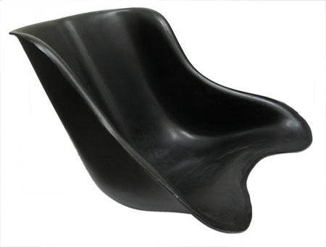

Fig-9.6 Correct Seat

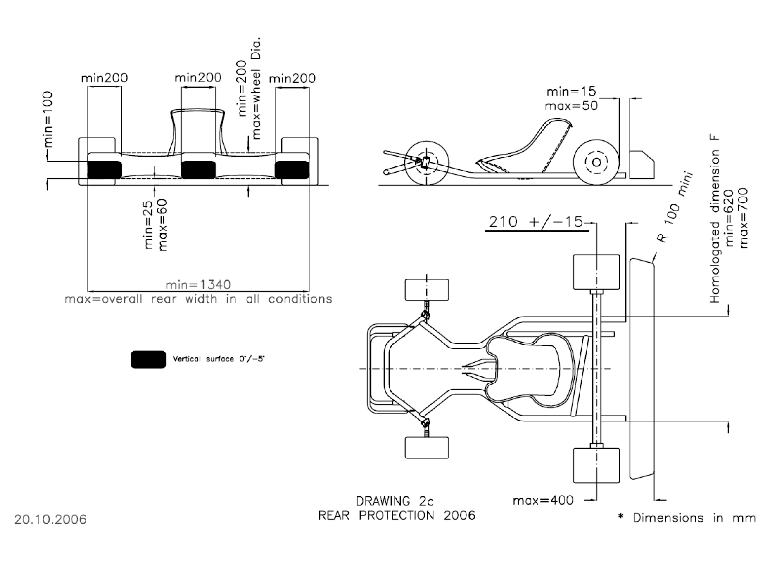

Fig-9.7 Technical Drawings

.

1. **Aesthetics**

Aesthetically, the frame design is improved by the use of spoiler which contributes in providing overall aerodynamic drag forces. The go kart is well balanced and color selection is such that it can be recognized from long distances. Various safety gears are installed.

1. **Ergonomics**

The dictionary meaning of ergonomics says it is an applied science concerned with designing and arranging things people use so that the people and things interact most efficiently and safely.

The ergonomics of go-kart includes the alignment of Steering, Brake pads, Accelerator pads, Driver seat, Safety Seat belts, Alignment of head support, Distance between driver’s seat and pads, Distance from the engine and orientation of seat. The parameters should be so arranged and placed that the posture of driver while driving should be proper and right which provides him enough comfort and safety while driving. This kart meets all the standards of ergonomics.

The steering is left aligned and at a distance of 36.2cm from left end and 41.2 cm from right end

The brake pads come on the left leg of the driver and accelerator pads on the right leg of the driver. The driver seat is at a distance of 76.7 cm from the brake and accelerator pads. The safety belts comes from top right of seat and ends at left hand side of the driver hence providing complete safety against jerks during motion of kart. The seat is also provided with head support that keeps proper position of head while driving. The height of the seat including head support is 170cm. The seat is at a safe distance from the engine and also the engine is shielded to protect the drivers from the heat given out from the engine. The seat is aligned towards left that allows the driver to easily access the accelerator pads and brake pads along with the steering.

The analysis after the driver is in seat gives the following results,

* Knee Angle 150- 170 degrees
* Elbow Angle 112-170 degrees • Neck Position Slightly Bent.

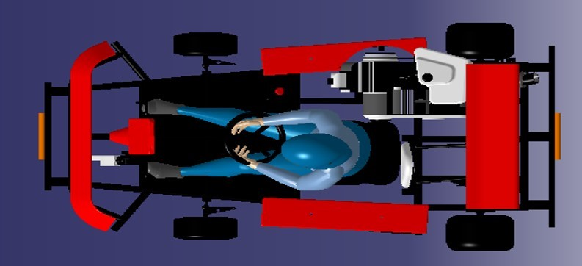

Fig-11.1 Top View of kart with Driver

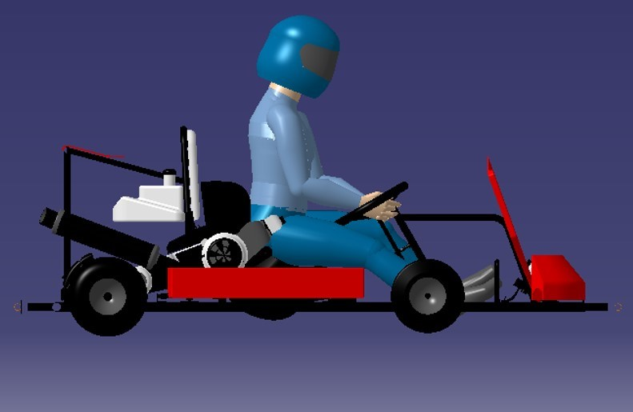

Fig-11.2 Side View of kart with Driver

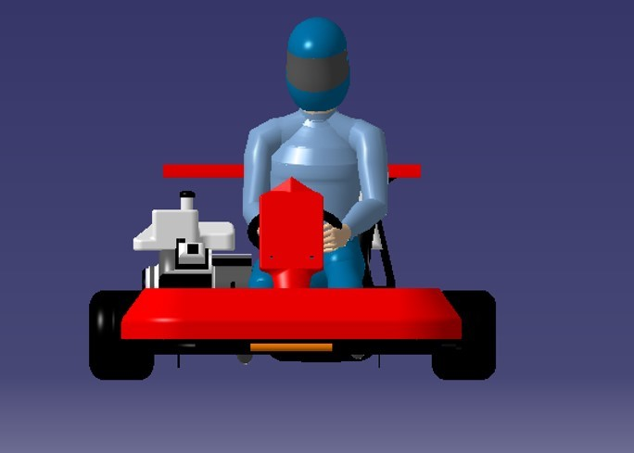

Fig-11.3 Front View of kart with driver

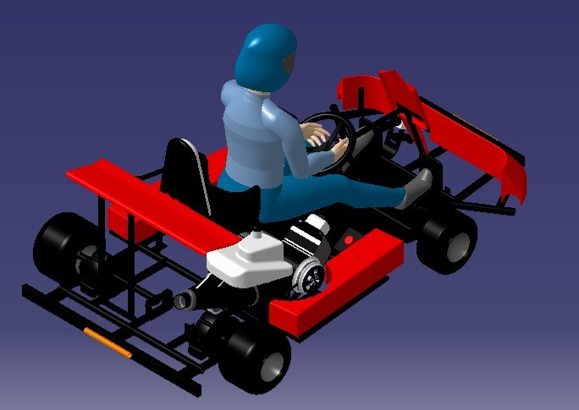

Fig-11.4 Rear Isometric View of kart with driver

1. **Safety Protocols**

The go-karts are designed for race and recreational purpose so the safety of driver is of prime importance. While designing and fabricating of go-kart the certain safety standards should be followed. The safety gears that are used in our go-kart are,

1. Seat Belt.
2. Fire extinguisher.
3. Faring and Body Works.
4. Engine Shield.
5. Chain Guard.
6. Rear View mirror

The seat belt comes from top right of seat and ends at left hand side of the driver hence providing complete safety against jerks during motion of kart. The seat belt is made of Nylon and polyester webbing which are generally used in seat belts of racing karts.

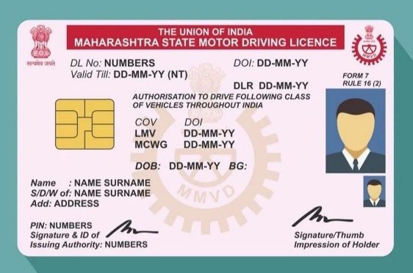

Fig-12.1

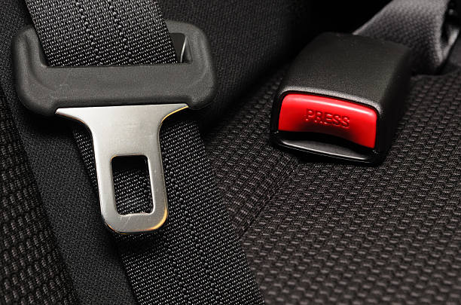

Fig-12.2

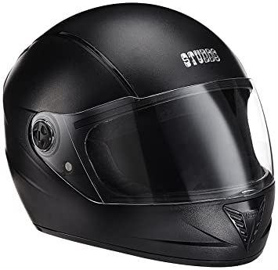

Fig-12.3

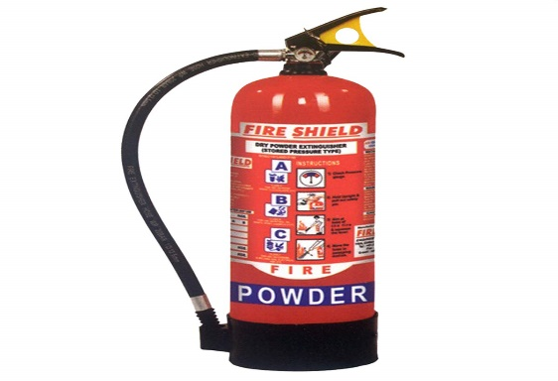

Fig-12.4

Two Fire extinguishers are installed, One at the rear of the kart and other at front of the kart within the reach of driver. The fire extinguisher is installed so that if by any chance the kart catches a fire the driver can use it to extinguish the fire thus ensuring the safety of driver. The farings made up of FRP is used as body work to prevent the direct impact on the chassis and main frame of the kart. The farings are used in rare, front and both the sides of kart thus preventing kart from direct impact during side bumping , head on collision and rear impact. Engine shield is made of refractory material that do not lose its property due to heat transferred by the engine.

The chain guard covers the chain. It prevents the damage to body works and provides safety to driver in case it leaves the sprocket due to malfunctioning. Rear view mirrors on both sides of the steering wheel are very important during taking sharp turns. The mirrors also help in situations where opposition karts are trying for overtaking maneuvers.

1. **Cost Report**

* Steering System – 1000
* Wheels – 3200
* Safety – 2000
* Electric motor – 5000
* speed controller – 2500
* Battery – 9000
* Braking System – 2000
* Wiring – 1000
* Body – 3000
* 28700

1. **Business Plan**

Marketing & Capital Generation

STEP 1: Capital generation through Recreation

STEP 2: Market survey of existing go-kart circuits in NCR

1. Identification of viable, business friendly & established enterprise.
2. Negotiation for a possible joint venture with the existing enterprise.

STEP 3: Terms & Conditions 1. Profit sharing.

1. Extensive marketing & publicity.
2. Possible business agreements with 3rd party establishments.

*Marketing:*

* + - * Advertising and publicity through radio, social media, billboards and at bus-stops.
      * Further publicity through tie-up with allied entertainment services such as Food Coupons and Movie Tickets.
      * Conditions for such offers to be valid only on certain benchmarks.

E.g. completing the lap before the predetermined time frame.

* + - * Special and exciting offers during weekdays.
      * Revenue generated through such a venture to be directed towards the creation of similar ventures in other marketable areas. E.g. Tier II cities.
      * Age group targeted: 18-25 yrs.
      * Further marketing to be done through high-schools with the help of educational workshops.
      * Estimated time for establishing the Recreational Activity: 2-2.5 years.

Starting Pro-Racing

➢ Preliminary steps to be undertaken:

* + - * Research analysis of Formula 5 and go-kart competitions taking place at an All India Level.
      * Capital generated from recreational activities to be utilized in setting up and conduction an All India competition preferably taking place in National Capital Region.

➢ Strategy:

* + - * + Preparation and analysis of conducting the competition to begin from a year and half prior to the dates of the competition.
        + Necessary affiliation of the event with technical societies having a history of conducting similar events at national level such as, SAE and bagging sponsorships from renowned Automobile majors.
        + E.g.: Automobile manufacturing companies, Automotive component companies, Lubricant companies.
        + Popularizing the event at national university level through social media, university visits by company associates.
        + Uprising the respective colleges about the level of the competition, incentives given in the form of Prize Money.
        + Further popularizing via radio, advertisements and through constant intimations to colleges.

Tying-up with the racing tracks for the competition to take place

➢ Execution:

* + - * Opening registrations 8 months prior to the competition.
      * Charging a minimalistic registration fee of about 6000/-.
      * Supplying the participants with respective specifications regarding the design and fabrication of the vehicle.
      * Conducting inspections in participating colleges for assimilation of preparation done by the participating colleges.
      * Supplying engines and allied components at subsidized rates.
      * Intimating the participants of any impending changes in the competition schedule or technical specifications.
      * Conducting the competition with assistance from technical societies.

➢ Future aspects:

* + - * Making contacts with prospective organizations, investors.
      * Gaining technical experience from various entries.
      * Generating capital to grow our competition by taking it to a big level and further investments.

Promoting Make in India campaign by successfully running the plant.

Plant Setup

* + - * Taking land on lease from Govt. authorities/ known contacts in Bahadurgarh, Haryana.
      * Constructing shop floors (body shop, assembly line, testing facility, packaging and transportation bay).
      * Setting up of assembly line and material handling equipment.
      * Installation of CNC, Robotic Welding, Automatic and Manual Lathe.
      * Testing facilities to include Non-Destructive Testing arrangements like Shot Blasting, Ultrasonic Testing, Luminous Magnetic Particle Inspection, Eddy Current Inspection.
      * Testing track having number of obstructions to test acceleration, braking, banking and steering and also a crash testing facility.
      * Recruitment of skilled and unskilled workers.
      * To function on a 7 hour a day shift.

Targeted Customers

* + - * Race circuit owners with whom we have had previous business terms.
      * Providing professional racing teams with internationally certified karts.
      * Creating company owned racetracks in market-friendly areas.
      * Providing assured quality and maintenance services across all spectrums.

1. **Future scope and improvement** 
   1. Modification of the current go kart can be done to participate in future design and fabrication projects and challenges.
   2. The practical knowledge gained can be utilized for future research on automobile and race engine design.
   3. Ball bearing can be fitted in the split axle to give more differential to the two tires. A concept we are working on but has to be tested.
   4. Paddle shifts can be used in place of manual gear shifting for ease of use.
   5. Conventional engine can be replaced by a bio-fuel or an integrated fuel and electric engine (hybrid engine) to minimize environmental pollution and low cost.
   6. Enhanced composite materials can be used for weight reduction leading to a better control, stability and pickup

1. **–Conclusions**

The purpose of this project was to fabricate a fixed axle/single axle go kart based on a conceptual design which is optimized to increase the stability and maneuverability of the vehicle on the racing track. The design is based on rulebook which is affiliated to. The design and fabrication of the Go-kart focuses on developing a simple, lightweight and easily operated vehicle. Aspects of ergonomics, safety and reliability were incorporated into the design specifications. Analysis were conducted on all major components to optimize strength and rigidity, improve vehicle performance and to reduce complexity and manufacturing costs.

|  |  |  |
| --- | --- | --- |
| Comparison between actual and desired parameters | |  |
| Parameters | Desired | Actual |
| Wheelbase | Min:101cm Max:107cm | 109cm |
| Track | Atleast 2/3 of the wheelbase | Front: 102cm Rear: 105cm |
| Overall Length | 182cm maximum without fairings | Overall: 206cm, 182cm without fairing |
| Height | Max 65cm from ground | 65cm from ground |
| Overall width | Max 140cm | Max 125cm |
| Ground Clearance | Sufficient to prevent any other portion of the vehicle from touching the ground | 9cm without considering sprocket and disc brakes |

Table-17.1 Final Go-kart

1. **References**
2. Asfan Mohiuddin, Mohd Sayeed, Md Nawaz “Steering System of Electric Go-Kart” International Journal for Research in Applied Science & Engineering Technology (IJRASET) Volume 5 Issue I, January 2017, IC Value: 45.98 ISSN: 2321-9653,Page 453-456. 2.Mohd Anwar, R.suman, Mohammed Salman, Vainateya, “Transmission System of Electric GoKart” International Journal Research in Applied Science & Engineering Technology (IJRASET), Volume 5,Issue I, January 2017, IC Value:45.98, ISSN: 2321-9653, Pages 445-452.JVHH 3.Govardhana Reddy, Md. Hameed, “design report of a go kart vehicle”, International Journal of Engineering Applied Sciences and Technology, 2016,Vol. 1, Issue 9, ISSN No. 2455-2143 , Pages 95- 102, Published Online July – August 2016.

[www.cikfia.com](http://www.cikfia.com/) Official site for the **CIK**-**FIA** World Karting Championship. Includes schedules, entry forms, news and member information.

[www.vintagekartscollection.com](http://www.vintagekartscollection.com/)

Alex Peslak, Alex Kattamis and Steve Ricciardelli. “E-Racer: An Electric Go-Kart.” University ofConnecticut. NSF 2001 Engineering Senior Design Projects to Aid Persons with Disabilities.

Retrieved on 25 September 2008.

<http://www.engin.swarthmore.edu/academics/courses/e90/2005_6/E90Reports/EK_DM_fin al.pdf>

Joel G. Landau, James J. LaPenna and Todd M. Piche. “Recreational Electra-Scooter for Special Children: A Fixed-Radius-Turn, On-Off-Control Wheelchair Carrier.” State University of New York-Buffalo. NSF 1994 Engineering Senior Design Projects to Aid the Disabled. Retrieved on 25 September 2008. <http://nsfpad.bme.uconn.edu/1994/chapter_8.pdf>.

GKDC Rulebook 2015

ISK Rulebook 2015

Chassis design by Herb Adams

Automotive Mechanics by Crouse Angeline

Theory of machine by R.S. Khurmi

F.O.V.D. by Thomas D Gillespie

CATIA V5 Reference Guide, CADDCENTRE

Project Planning Reference Guide, CADDCENTRE

DIY Gokarts Forum <http://www.diygokarts.com/>